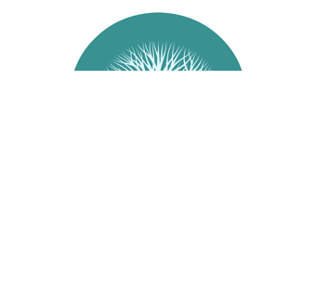
Membership Form

For residents and business people alike who care about their Community.
Take an interest and join us helping to shape our community.
Incorporated in February 2003, Success Residents Association represents our community.
With direct contact with the City of Cockburn, their councilors, Government Departments and other community building bodies, SRA will actively pursue any matters or issues on behalf of the residents.
New input, feedback, matters and members are always welcome.
Meetings for 2012 | Contacts
MEETINGS | CONTACTS
Bi Monthly General Meetings.  Commences at 7.00pm | Email: successresidents@gmail.com  Postal: P O Box 3597 Success WA 6964
Cockburn Youth Centre
25 Wentworth Parade, Success
SRA Membership Form
Name: __________________________________________________________________________________________________________
Address: _______________________________________________________________________________________________________
Email Address: ________________________________________________________________________________________________
Phone: (H)_______________________________________________(M)__________________________________________________
Membership Fee: $5.00 per year. To be renewed each year by 30 June. Receipt No.___________

Membership Form and Fee to be handed to Treasurer at the next General Meeting.

